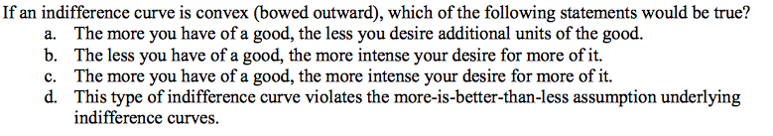

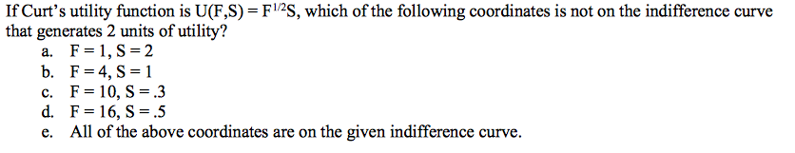
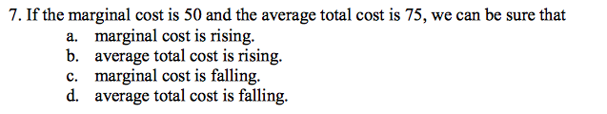
9. Average total cost is $200 for a given output, total fixed cost is 100 and average variable cost is 140. What is the quantity being produced?

11. Suppose Bill views butter (b) and margarine (m) as perfectly substitutable for each other. His utility function is U(b,m)=b+m Are these indifference curves convex (draw indifference curve with given information above)? And why?
12. Suppose a firm has a cost function C(q)=4$q^{2}$+16
a.) Find its variable cost, fixed cost, average total cost, average fixed cost, average variable cost.
b. Find the output level that minimizes average total cost and corresponding value of average total cost (ATC) where marginal cost is 8q (MC=8q)
13. If the algebraic expression relating income to expenditure is shown as I= PxX + PyY, show, using simple algebra or graphical representation, that the slope of the budget line is -Px/Py if good X is on the horizontal axis.

